GOVERNMENT. DEGREE COLLEGE, GUMMALAKSHMIPURAM



# Affiliated to Andhra University, Visakhapatnam

Report on National Science Day 2025

# Introduction

Every year on February 28, India celebrates National Science Day, honouring Sir C.V. Raman's discovery of the Raman Effect. This day seeks to raise public awareness of science and its applications to everyday life, as well as to encourage a scientific temper among the public. in keeping with this spirit. To celebrate National Science Day in 2025, Government Degree College in Gummalakshmipuram, Parvathipuram Manyam district, arranged a number of events and activities.

# Theme of National Science Day 2025

The theme for National Science Day 2025 is “Science and Innovation for Viksit Bharat”. The importance of science and technology in addressing global issues and building a more sustainable future for everybody is highlighted by this theme.

**Climate change:** Creating strategies to lessen its effects and support renewable energy sources. **Resource depletion:** Investigating sustainable management of natural resources such as food, energy, and water in the face of resource depletion.

**Degradation of the environment:** Putting pollution prevention, waste management, and biodiversity conservation measures into practice.

**Sustainable development:** Sustainable development is the process of incorporating technology and science into development plans in order to achieve both environmental protection and economic growth.

# Objectives:

The objectives of National Science Day 2025 were outlined, emphasizing the promotion of scientific inquiry, innovation, and the exploration of solutions to global challenges.

**Inaugural Ceremony:** The day began with an inaugural ceremony attended by faculty members, students, and the Principal of the College. Addressing to the gathering, **Principal Dr. T.Sreevaram** enlightened the students that every activity in the environment is connected with Science and Technology He motivated the students to give attention to observations of scientific activities in day-to-day life.

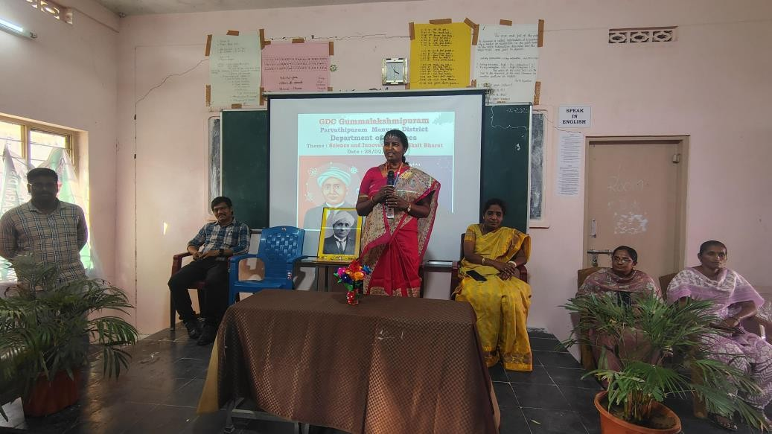

Addressing the gathering and highlighted the latest innovations in science and technology. She expressed the position of our country in journals publishing data base, Scopus. She also enlightened the gathering about the theme of this year Science day i.e,“Science and Innovation for Viksit Bharat”.

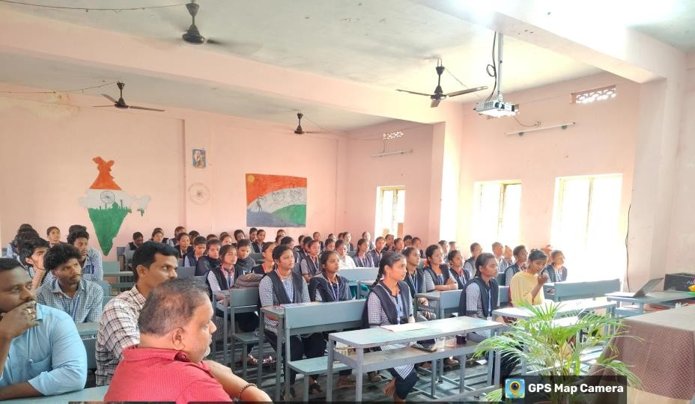

# Science Exhibition was conducted among the students

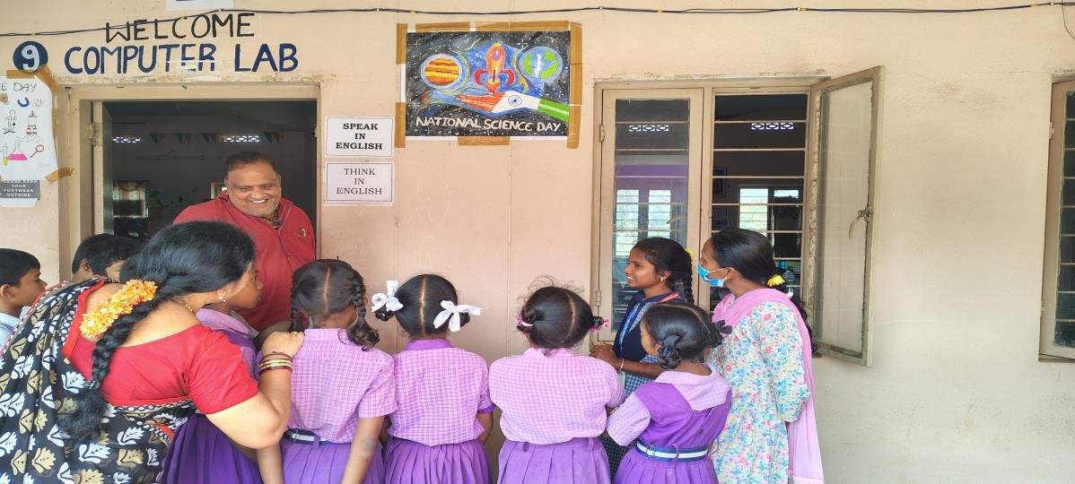

**Students** gave speech on the life story and invention of Sir. C. V. Raman

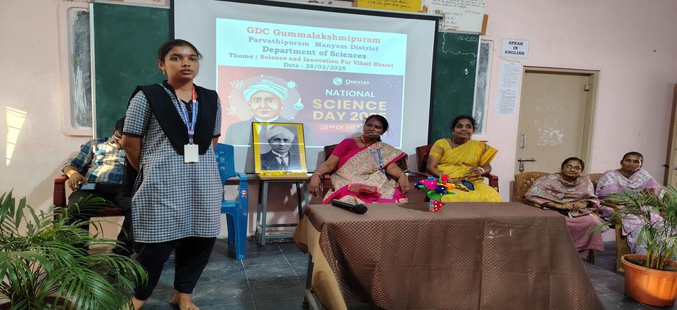

**Students** highlighted the latest advancements in Science and Technology

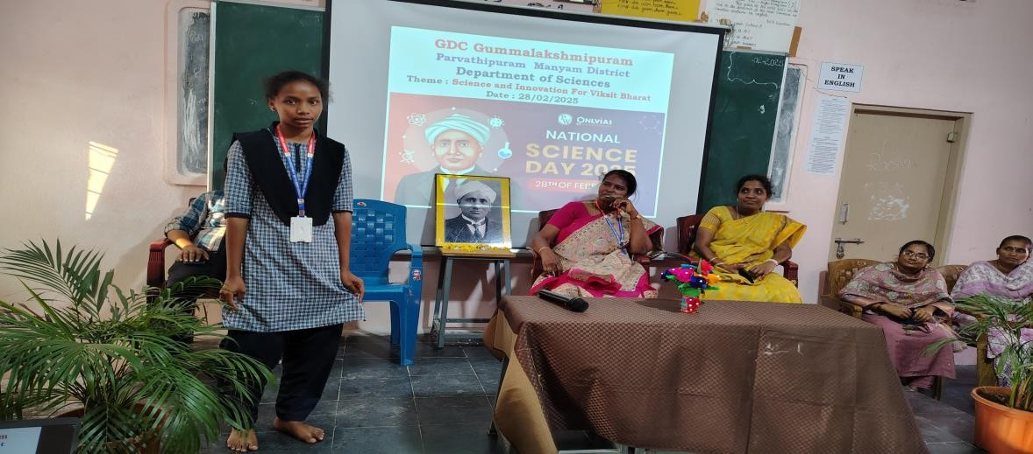

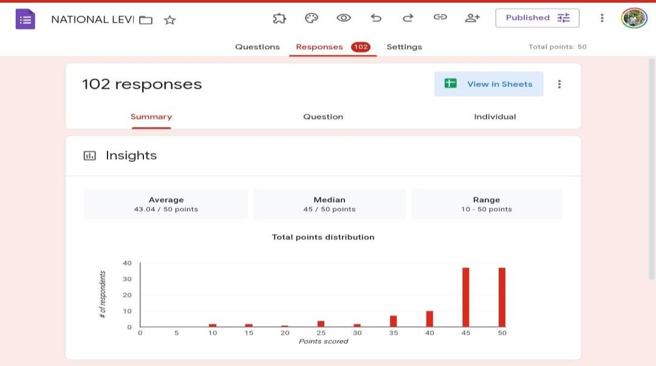

# Online EQuiz on National Science Day

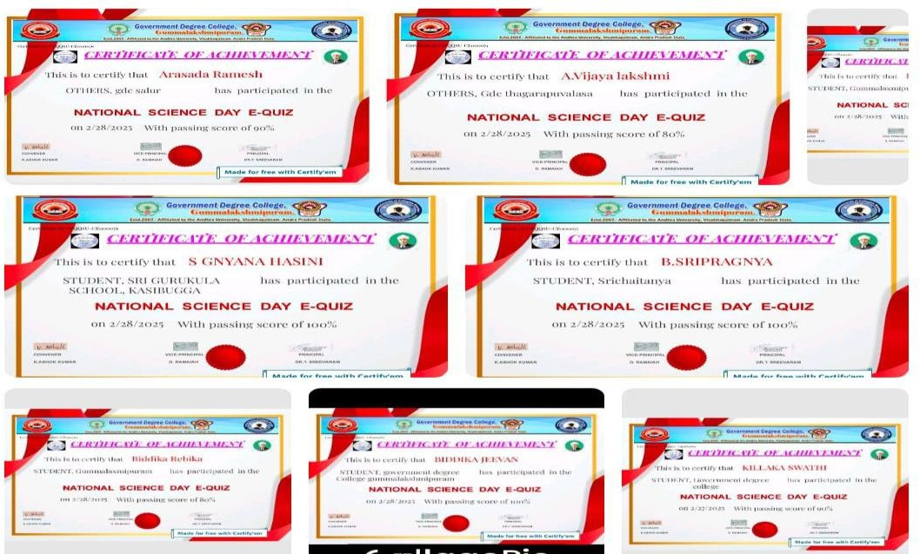

**E- Certificates of Participants for Online Quiz**

**Acknowledgment: Vice Pr**incipal Sri D Ramaiah gave vote of thanks and heartfelt gratitude to all participants, including students, and faculty, for their enthusiastic participation and valuable contributions to making this celebration a memorable and impactful one. Special thanks to our esteemed **Principal Dr. T.Sreevaram** for his insightful contributions and encouragement. Appreciations to **Sri Chinna**rao, Lecturer in Chemistry, **Sri K** Ashok Kumar Lecturer in Computer Science, **Smt. G.Tulasi**, Lecturer in Mathematics, **Sri. T Satya ,** LecturerinBotany.

